Project Title: AI Biz
Problem Statement
Small and medium-sized businesses generate a lot of information from sales reports, financial statements, customer feedback, inventory records, and operational data. However, managers often struggle to interpret this information and make informed decisions quickly.
Traditional Business Intelligence tools provide dashboards and charts but do not explain why trends occur or recommend actions.
The proposed system addresses this challenge by using Artificial Intelligence to analyze business information, generate insights, identify risks, forecast trends, and provide actionable recommendations.
Objectives
General Objective
Develop an AI-powered Business Intelligence platform that assists organizations in making data-driven decisions through intelligent analysis and recommendations.
Specific Objectives
- Upload business reports and datasets.
- Automatically summarize business performance.
- Detect trends and anomalies.
- Forecast future sales or revenue.
- Identify business risks.
- Provide AI-generated strategic recommendations.
- Allow users to ask business-related questions in natural language.
- Generate executive reports.
Core AI Modules
1. AI Data Interpreter
- Reads uploaded CSV, Excel, or PDF reports.
- Understands columns and metrics.
- Explains the contents in plain English.
2. Executive Summary Generator
Instead of reading a 50-page report, executives receive:
"Revenue increased by 12% this quarter, driven primarily by strong product sales in the West region. Customer retention improved by 8%, while inventory costs rose by 15%."
3. Business Insight Engine
Automatically answers questions like:
- Why did revenue decrease?
- Which products perform best?
- Which customers generate the most revenue?
- Which regions are underperforming?
- What trends are emerging?
4. Risk Detection Engine
The AI detects potential issues such as:
- Declining sales
- Rising operational costs
- Customer churn signals
- Low-performing products
- Inventory shortages
- Cash flow concerns
5. Recommendation Engine
Rather than only identifying problems, it suggests actions, for example:
- Increase stock for Product A.
- Reduce marketing spend in Region X.
- Focus promotions on returning customers.
- Adjust pricing strategies.
6. AI Business Chatbot
Users can ask questions such as:
- "Which product generated the highest profit?"
- "What caused the drop in sales last month?"
- "Predict next month's revenue."
- "Which branch needs improvement?"
The chatbot answers based on the uploaded business data.
7. Forecasting Module
Predict:
- Sales
- Revenue
- Inventory demand
- Customer growth
using AI models.
8. Report Generator
Generate:
- Executive reports
- Performance summaries
- Business recommendations
- PDF reports

Architecture

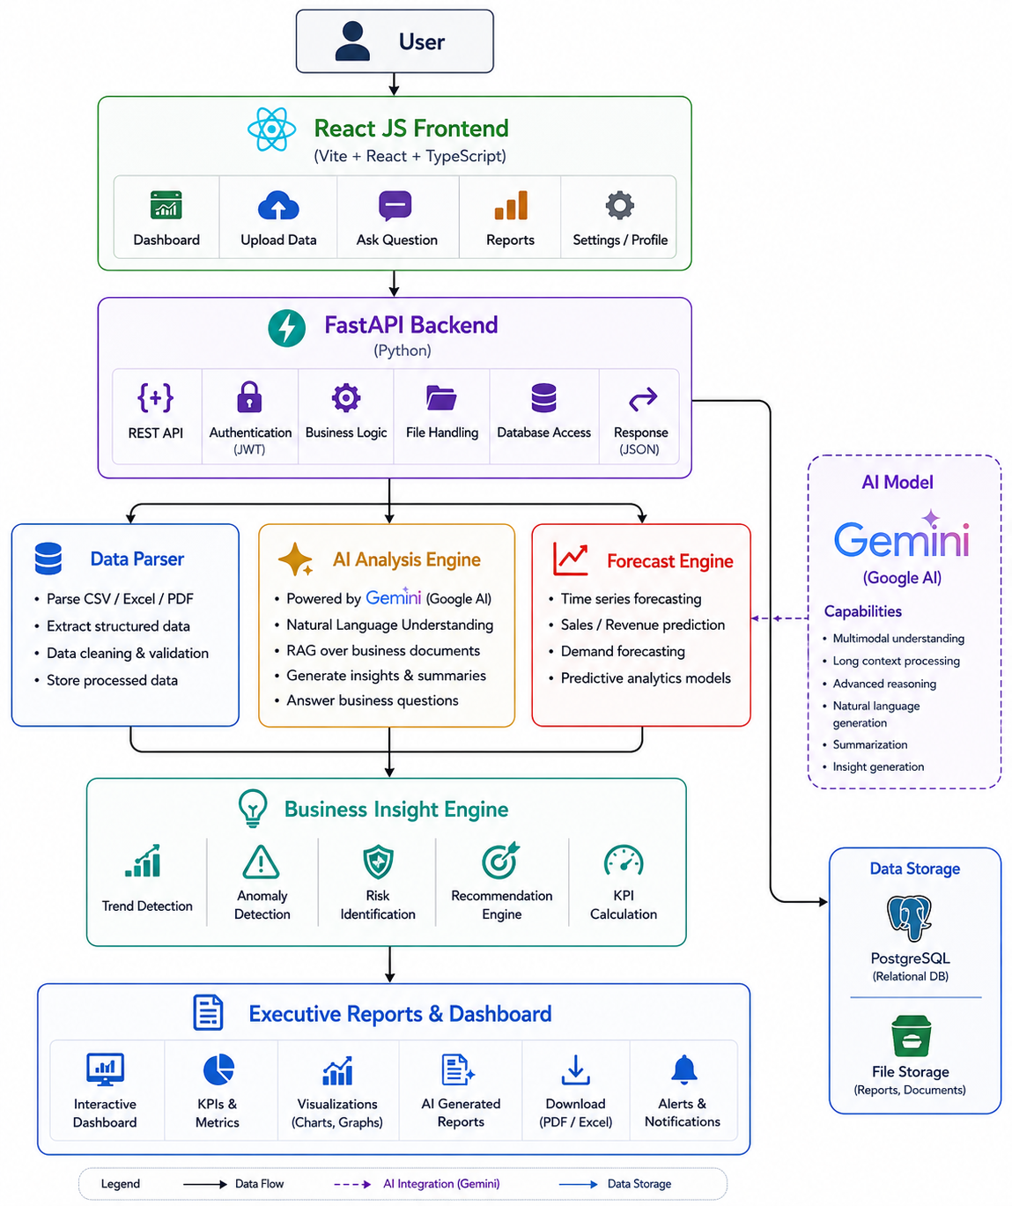

Technologies
- Backend
- Python
- FastAPI
- Frontend
- React js
- AI
- Gemini
- LangChain
- RAG (to answer questions from uploaded business documents)
- Machine Learning
- Scikit-learn
- Prophet or another forecasting library (optional)
- Data Processing
- Pandas
- NumPy
- Visualization
- Plotly
- Matplotlib
- Database
- Supabase

